**UPLOAD A FILE In BUCKET “PGDCSL-SRC”**

**COPY THAT FILE INTO “PGDCSL-dst”**

**Made a bat file for the same –**

**Ass.bat file -**

set /p FileName=Enter the name of the file to upload:

set /p BucketName=Enter the name of the S3 bucket:

aws s3 cp "%FileName%" "s3://%BucketName%/"

set /p CopyDestination=Enter the destination path to copy the file to:

aws s3 cp "s3://%BucketName%/%FileName%" "s3://%CopyDestination%/"

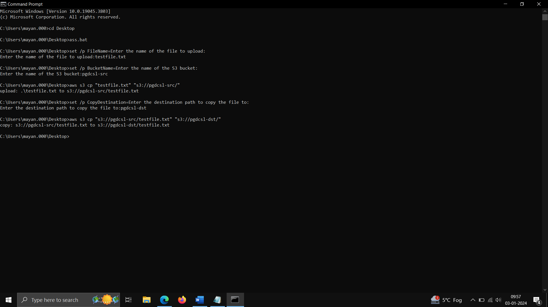

POC -made a file mayank.txt/testfile.txt –

Upload in pgdscl-src bucket

Command - aws s3 cp "testfile.txt" "s3://pgdcsl-src/"

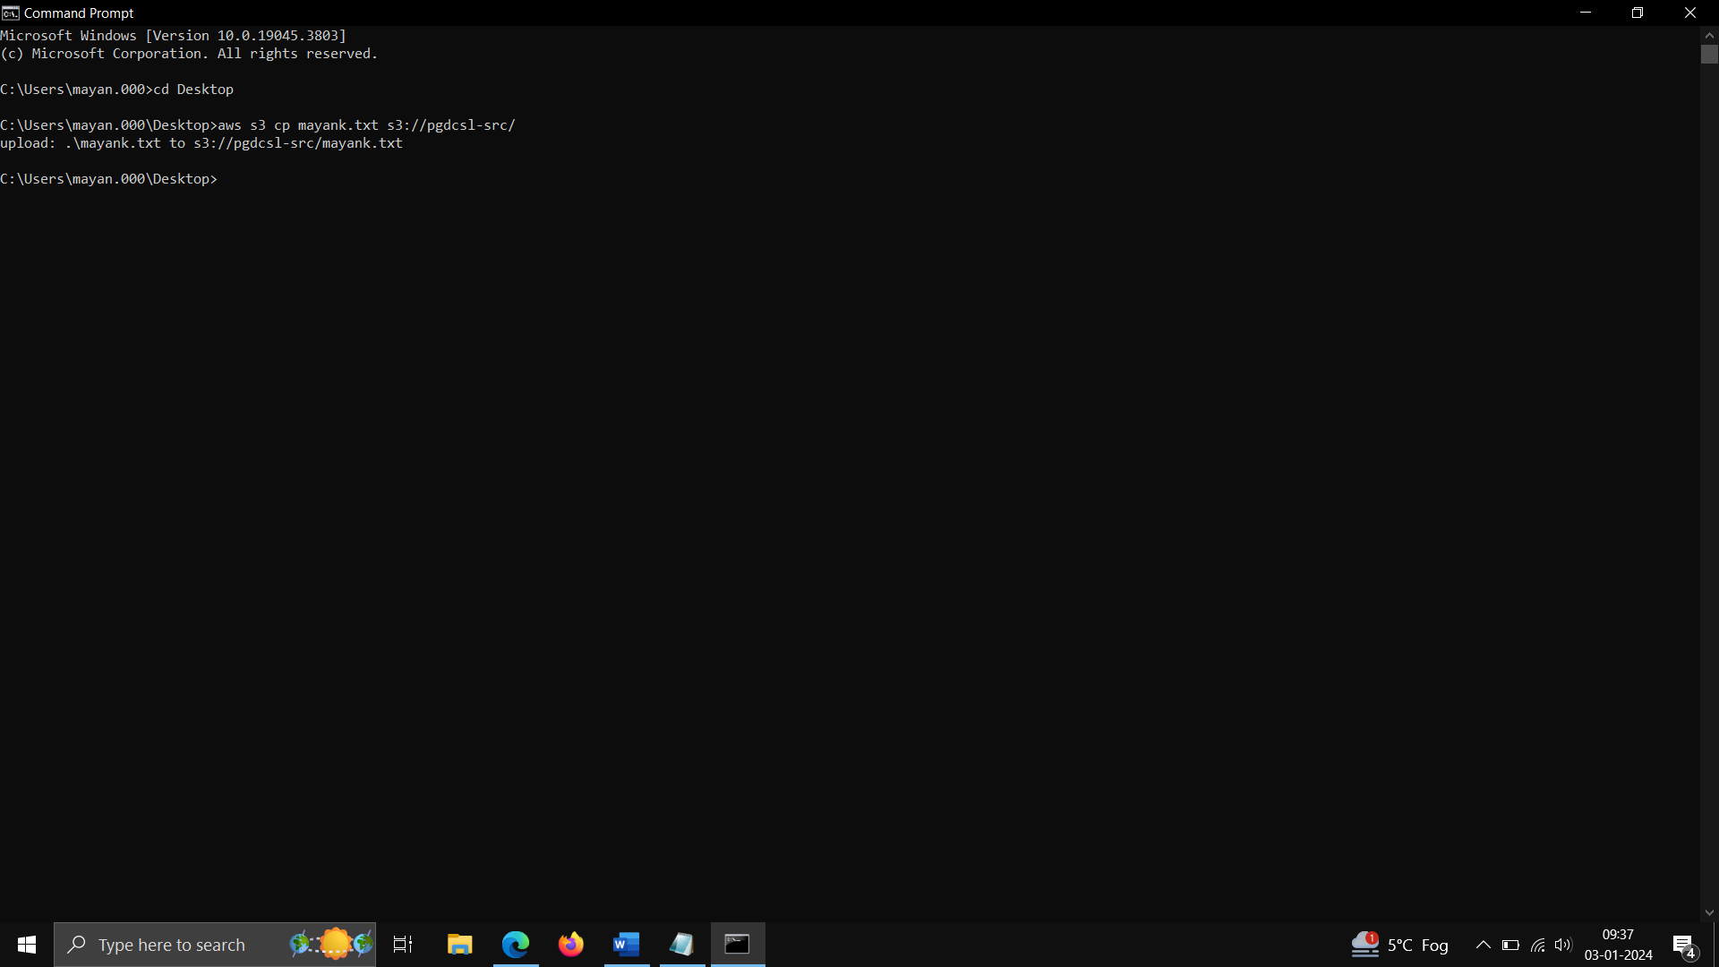

Copy that file in pgdcsl-dst bucket –

aws s3 cp "s3://pgdcsl-src/testfile.txt" "s3://pgdcsl-dst/"

